Assignment Screenshot 2

1. Inserting Five New Documents in the existing collection

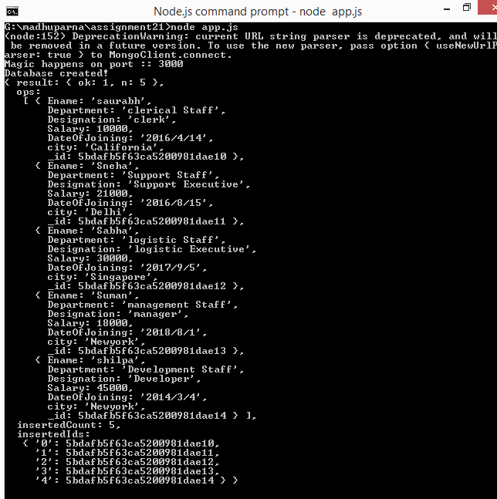

1. Showing result in local host

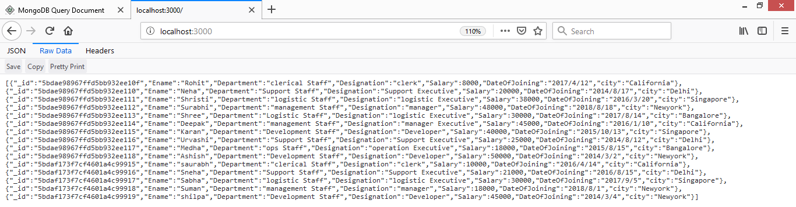

1. Deleting records with designation developer

